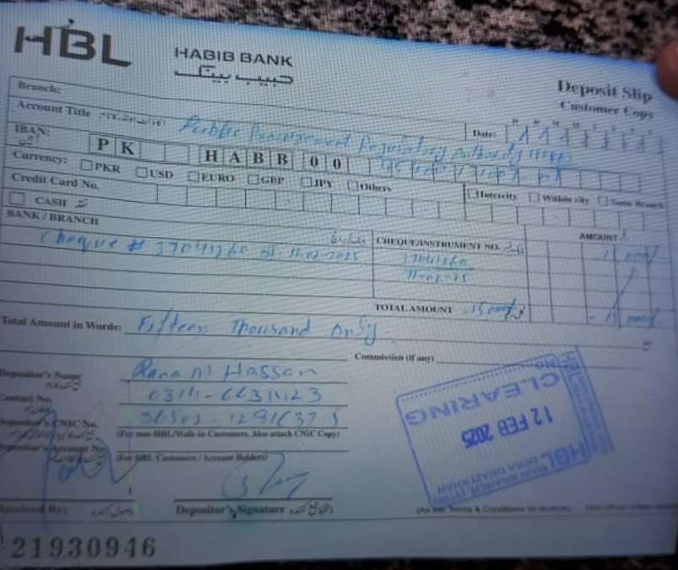
TENDER NOTICE NO. 07/2025
TENDER NOTICE FOR THE PURCHASE OF AUTOCLAVE / TABLE TOP STEAM STERILIZER THROUGH OPEN TENDER

- A Public Sector General Hospital invites sealed tenders from eligible / reputed firms / suppliers registered with income tax / general sale tax department for the purchase of autoclave / table top steam sterilizer on FOR basis at D.G Khan under single stage – two envelopes bidding procedure from the eligible tenderers / suppliers / manufacturers for the following items.
Sr. # | Tender # | Description | Tender Fee | Last Date / Time of Bid submission | Bids Opening Date / Time
1. | 07/2025 | Autoclave / Table Top Steam Sterilizer | 2,000/- | 25.02.2025  At 10:00 Hrs | 25.02.2025  At 10:30 Hrs

- A set of tender documents along with terms and conditions can be downloaded from PPRA website: www.ppra.org.pk at a cost of Rs. 2,000/- payable in the shape of “Pay Order/Demand Draft” in favor of “Head LAO, Public Sector General Hospital, D.G Khan”. The Pay Order/Demand Draft and tender request must be submitted along with tender proposals before closing date of tender. No Tender / Proposal will be accepted without Tender Fee.
- This tender can be seen on PPRA website www.ppra.org.pk also.

- The competent authority reserves the right to reject any or all the tenders.

Admin Officer
Public Sector General Hospital
H-11/4 Islamabad
Ph: 051-9257171
Ext: - 289

INSTRUCTIONS
TO FILL UP THE TENDER DOCUMENTS
Technical worksheet

- Download file named “Tender File Autoclave / Table Top Steam Sterilizer” from URL: www.ppra.org.pk for quoting technical specification of “USG Machine”.
- Open relevant file.
- Save the file when it is complete to fill up the cells of as many brands as you want to quote.
- Please write “NQ” against non-quoted items in empty cells.
- Technical Proposal should not indicate any price. There will be two different envelopes, one for Technical Proposal only and one for Financial Proposal. All pages of hard copy should be stamped, signed and with dated of Technical Proposal. The format of which is contained in the required proposal attached with tender documents available at PPRA website.
- In addition to the hard copy, a soft copy as CD / Flash Drive should also be submitted with the technical proposal in MS Excel / MS Office format.
- The hard and soft copies should be identical.
- Variation in hard and soft copy will not be acceptable.
- Put duly signed / stamped print-outs and CD / Flash Drive of “Technical” worksheet in an envelope and name it as “Technical Proposal” along with following documents:
- GST Certificate
- NTN Certificate
- Professional / Trade Tax Clearance Certificate
- Original Bank Draft of Earnest Money 2% of total value of equipment
- Valid Authority/ Distribution letter
- Original Bank Draft of Rs. 2000/- as Tender Fee (in separate enlovep)
- Agency agreement with manufacturer (foreign / local)

- Properly seal the envelope named “Technical Proposal”.

Financial worksheet

- Open same saved file again as above.
- Take print outs of “Financial” worksheet and sign & stamp each page.
- Write a CD / Flash Drive or “Save As” the file in CD / Flash Drive for making a soft copy of “Financial” worksheet (Keep it in mind that Technical worksheet will also be included in the saved file).
- Put duly signed / stamped print-outs and CD / Flash Drive of “Financial” worksheet in an envelope and name it as “Financial Proposal”.
- Put both the envelopes named “Technical Proposal” and Financial Proposal” in a large envelope and Mark it as “Tender for Autoclave / Table Top Steam Sterilizer” and properly seal it. Submit the tender documents to the specified address: Admin Officer, Public Sector General Hospital, H-11/4, Islamabad (PGHI) or directly drop it to the office of Admin Branch, Islamabad.
TERMS & CONDITIONS
PAKISTAN ATOMIC ENERGY COMMISSION
GENERAL HOSPITAL H-11/4
ISLAMABAD
PGHD-1(28)/24 Dated: -02- 2025

M/S _
________________________________
________________________________

Subject: TENDER ENQUIRY FOR THE SUPPLY OF “AUTOCLAVE / TABLE TOP STEAM STERILIZER” THROUGH OPEN TENDER FOR FINANCIAL YEAR 2024-25
Dear Sir,
The following instructions may kindly be complied with while forwarding quotations for the supply of “Autoclave / Table Top Steam Sterilizer” through open tender basis for financial year 2024-25 for FOR basis at D.G Khan Hospital, D.G Khan.

1. The quotations should be addressed to Admin Officer, Public Sector General Hospital, H-11/4, Islamabad. The bidders will submit their offers using single stage two envelopes bidding procedure as per following details: -

- The bid will be comprised of a Single Package containing Two Separate Envelopes. Each envelope will contain separately the “Technical Proposal” and the “Financial Proposal” in both soft and hard copy in the shape of CD / Flash Drive and print-outs respectively.

- The separate envelopes should be marked as “TECHNICAL PROPOSAL” and “FINANCIAL PROPOSAL” in bold and legible letters in order to avoid confusion.

- Initially only the envelopes marked “TECHNICAL PROPOSAL” will be opened.

- The envelopes marked as “FINANCIAL PROPOSAL” will be retained in safe custody without being opened until opening date for financial proposals.

- The technical proposal will be evaluated without reference to any Price and any proposal that do not conform to the specified requirements will be rejected.

- No amendment in the Technical Proposal will be permitted during evaluation.

- The Financial Proposal of the bids will be opened publicly at a specified time, date and venue announced and communicated in advance to the bidders of technically accepted bids only. The Financial proposal of the bids found non-responsive or without offered rates will be returned to the respective bidder and would be treated as cancelled.

- The firm will submit only one quotation against one tender document. For alternate quotations, if any, the firm will purchase separate tender documents and also will submit bid security along with each technical offer.

- Only those firms will be considered as eligible to participate in this tender, which would have stock available with them. The supply must be made within two weeks from the date of supply order.

General terms & conditions:

2. All the Technical Proposals and Financial Proposals in Separate Sealed Envelopes clearly marked as “purchase of Autoclave / Table Top Steam Sterilizer” financial year 2024-25 should reach the undersigned on or before the tender opening date i.e. 25-02-2025 up to 10:00am. Technical bids of USG Machine will be opened on 25-02-2025 at 10:30am in Conference Room, Public Sector General Hospital, Sector H-11/4, Islamabad in the presence of bidders who would have submitted their offers as per instructions/ requirements and intend to be present. In case of falling holiday on the opening date, the tenders will be opened on the next working day at the same time.
3. No tender will be considered if:-

- It is received after the time and date fixed.
- The tender and related documents are not signed.
- The offer is ambiguous.
- Items offered differ in descriptions/requirements/format etc. from those required.
- It is submitted without tender fee, earnest money or with less earnest money as a general policy.

4. Following Documents must be attached with Technical Proposal: -

- GST Certificate
- NTN Certificate
- Profession / Trade Tax Clearance Certificate
- Original Earnest Money
- Valid Authority/ Distribution letter (Punjab Region Only) (Items quoted without authority letter will not be considered)

5. The offered rates/quotation will be valid for 90 days.

6. Earnest money @ 2% total value of contract value in the form of Pay Order/ Bank Draft, in favor of Head LAO, PAEC General Hospital, D.G Khan must be attached along with the Technical Offer in separate sealed envelope. Financial proposal should contain only offered price / rate.

7. Earnest money will be returned to the unsuccessful bidders soon after finalization of the financial proposal.

8. The supplier is required to present his agency agreement (Punjab Region only) with the manufacturer (local or foreign) to establish linkage with the manufacturers for the products authorized for sale by the distributor. PGHI will have the right to verify authenticity of agency agreement.

9. The quantities to be purchased from the suppliers can be increased or decreased as per requirements of PGHD. The suppliers are to ensure timely delivery of equipments as specified failing to which liquidated damages / late delivery (L.D) charges will be applied @ 2% per day subject to a maximum of 10% of the purchase order.

10. Special Instructions: -

- GST / Income Tax will be charged as per prevailing Govt Rules

- Suppliers/Distributors are bound to submit a valid authority letter/sole distribution certificate (Punjab Region Only) for all the quoted brands failing which offer will not be accepted and the same must be attached along with the TECHNICAL PROPOSAL.

- No change will be allowed during the currency of contract in supplier’s distribution and the supply orders will be generated in the name of same supplier quoted in the tender.

- Rates must be quoted in the specified file available on PPRA website. Any proposal submitted without observing the instructions will be rejected.

- It should be clearly mentioned in your quotations (Both in Technical/Commercial) whether your quoted rates are inclusive OR exclusive of GST.

11. Any correspondence regarding this tender must be addressed to Admin Officer, Public Sector General Hospital, H-11/4, Islamabad only. For any additional information contact on telephone numbers mentioned below.

12. The Competent Authority reserves the right to accept or reject any or all the offers.

(Muhammad Anwar Kamal)
Admin Officer
Public Sector General Hospital, H-11/4, Islamabad
Phone: 051-9257171 Ext: 289
Fax: 051-9258862

TECHNICAL SPECIFICATIONS OF AUTOCLAVE / TABLE TOP STEAM STERILIZER

Following are the minimum requirements. Products offered must meet these parameters here in.
